**Audit and Analytics Services**

**BALANCING RULE PROCEDURE DEMO**

**Contents**

Understanding Balancing Rule Procedure Demo 4

Overview 4

Prerequisites 5

Creating an Application 5

Creating / Viewing the Policy 6

Creating a Task 8

Importing Rule Procedure 9

Deploying Rule Procedure 12

Viewing Run Status and Logs 12

Result 14

**Figures**

Figure 1: Sample Report File 5

Figure 2: Applications page 5

Figure 3: Create Applications screen 6

Figure 4: Tools 6

Figure 5: Policy Editor 7

Figure 6: Edit Policy 7

Figure 7: Edit Policy AC001_POLICY 7

Figure 8: Select App1 8

Figure 9: Create Folder/Task button 8

Figure 10: Create Folder/Task screen 9

Figure 11: Rule Editor 9

Figure 12: Open Rule Procedure 10

Figure 13: Rule Procedure Loaded 10

Figure 14: Primary Data Source 11

Figure 15: User Variables 11

Figure 16: First Active Rule 11

Figure 17: Deploy RP dialog box 12

Figure 18: Run 12

Figure 19: Run/Trace Log 13

Figure 20: Download Log File 13

Figure 21: Log Report 14

BALANCING RULE PROCEDURE DEMO

Understanding Balancing Rule Procedure Demo

By using this simple demo, it will be possible to extract data from a report and confirm if the sum of the ACTUAL MTD values match the value of TOTAL ACTUAL MTD. You can perform this task only if you have access to both:

* AAS Desktop Rule Editor
* Audit & Analytics Services application

Overview

This demo explains a simple rule procedure that extracts data from a report and verifies if the sum of ACTUAL MTD values matches the value of TOTAL ACTUAL MTD.

Below are the key files that would be used as part of the demo available under DATA directory:

* AC001page.rpt
* AC001_POLICY.PLC
* BalancingRP.xml

A sample (AC001page.rpt) report file is used to check the balance. In this report, the ACTUAL MTD values are marked in grey and the TOTAL ACTUAL MTD value are marked in green.

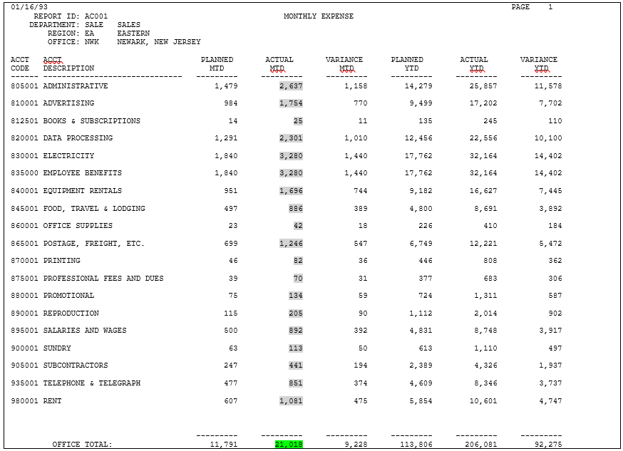

Figure : Sample Report File

Balancing Rule Procedure Demo will verify if sum of ACTUAL MTD values matches the value of TOTAL ACTUAL MTD.

Prerequisites

1. Install **Audit & Analytics Services** application.
2. Configure **Audit & Analytics Services** application using the User's Manual.
3. Ensure the application is up and running.

Creating an Application

1. Open the browser and hit the URL: http://{hostname/ipaddress}:{port number}/aaservices/view/. For example, <http://local>host:8079/aaservices/view/.
2. Log in to the application using the username and password.
3. Click **Applications** tab. The **Applications** page appears.

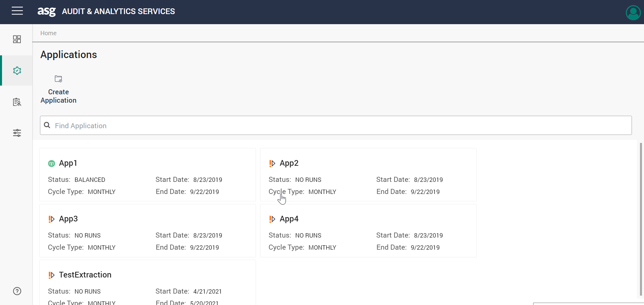

Figure : Applications page

1. Click **Create** **Application** button. The **Create Applications** screen appears.
2. Type “App1” in the **Name** box and disable the **Lock cycle on advancement** checkbox.
3. Click **Create**. An application will be created.

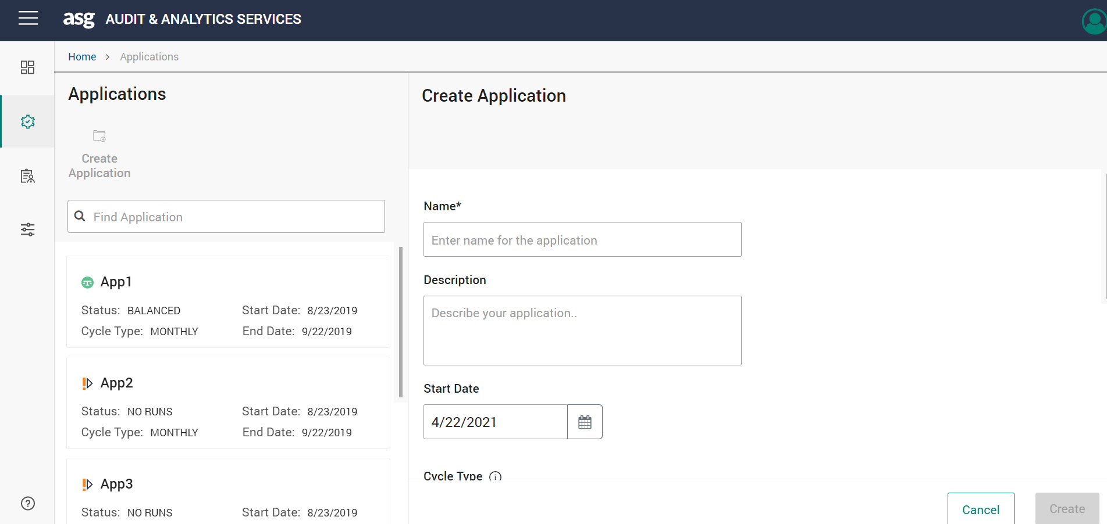

Figure 3: Create Applications screen

Creating / Viewing the Policy

A policy must be prepared which can be used to extract data from the report. For demo purposes, a policy of such nature was already prepared for this example AC001_POLICY.PLC.

1. Launch the Desktop Rule Editor and log in to the application.
2. Go to **Tools** > **Policy Editor**.

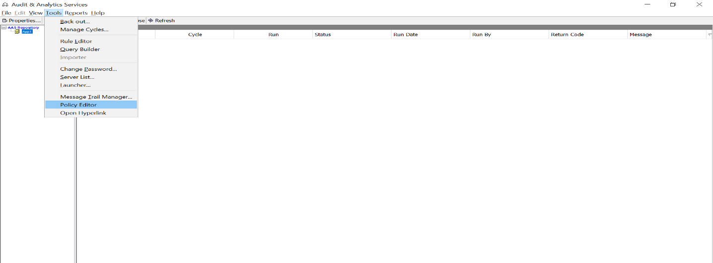

Figure : Tools

1. The **Policy Editor** window appears. Click **Browse** and select the AC001_POLICY.PLC file.

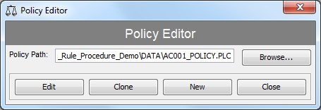

Figure : Policy Editor

1. Click **Edit**. The **Edit Policy** window appears.

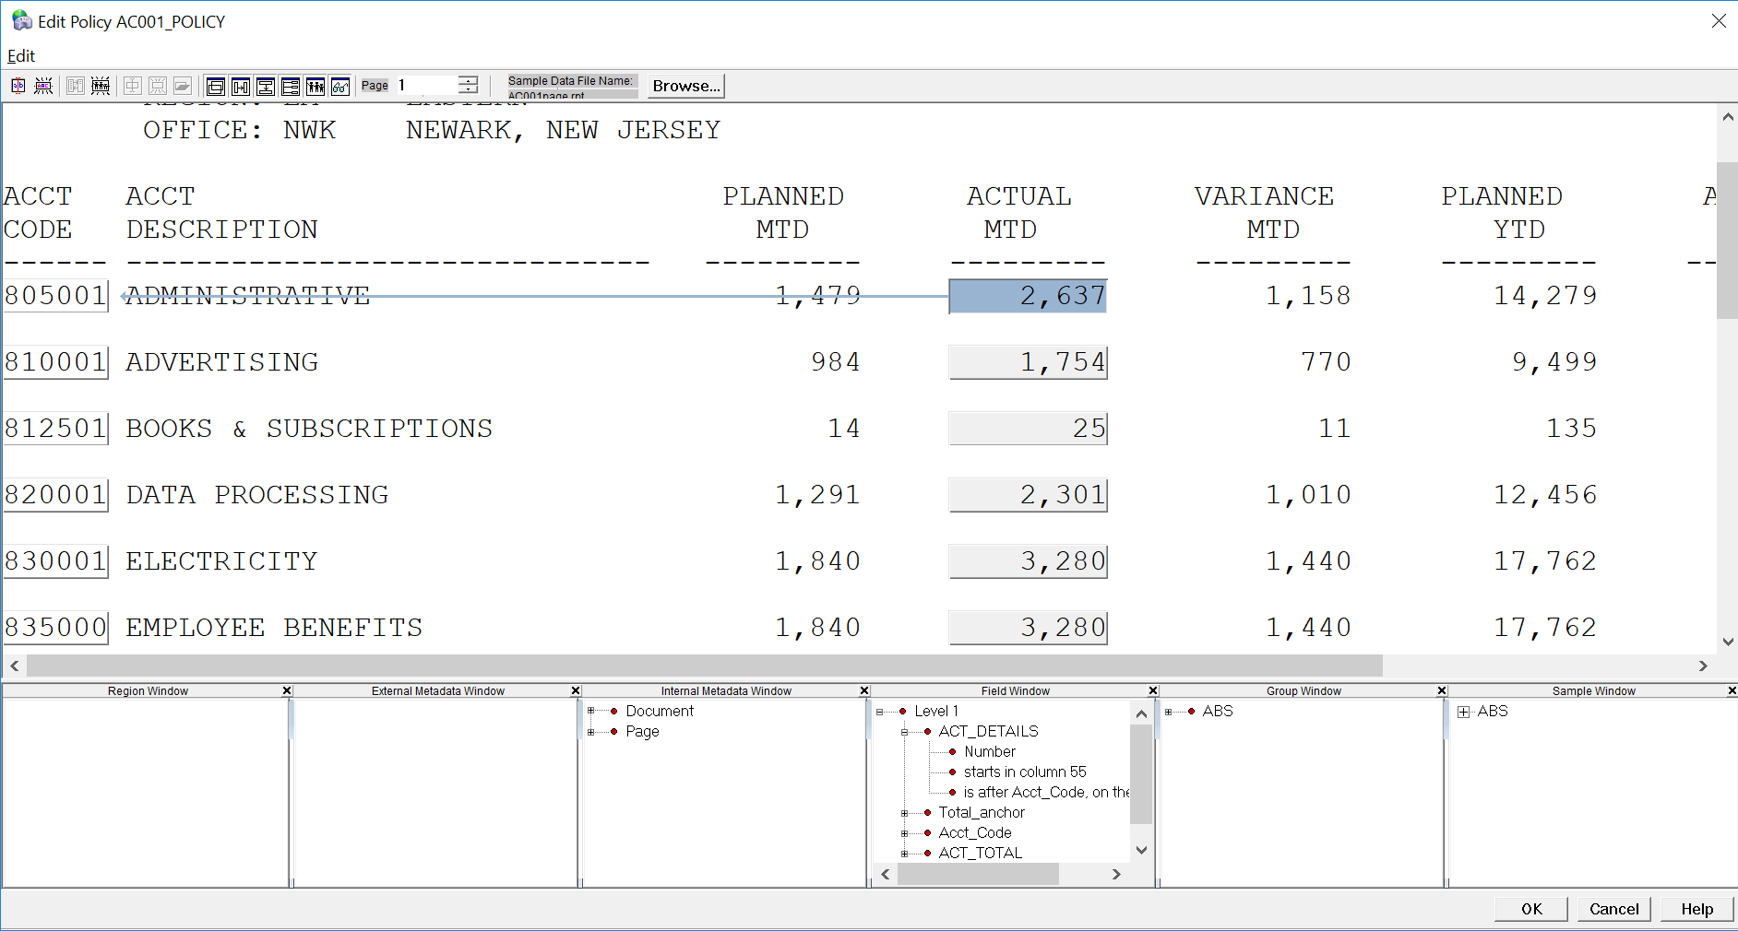

Figure : Edit Policy

This window allows us to edit the selected policy that will be used for data extraction from this report. The ACTUAL MTD column values are selected when one of the values is clicked as shown in the image above.

A separate field is defined for TOTAL ACTUAL MTD as shown in the below image.

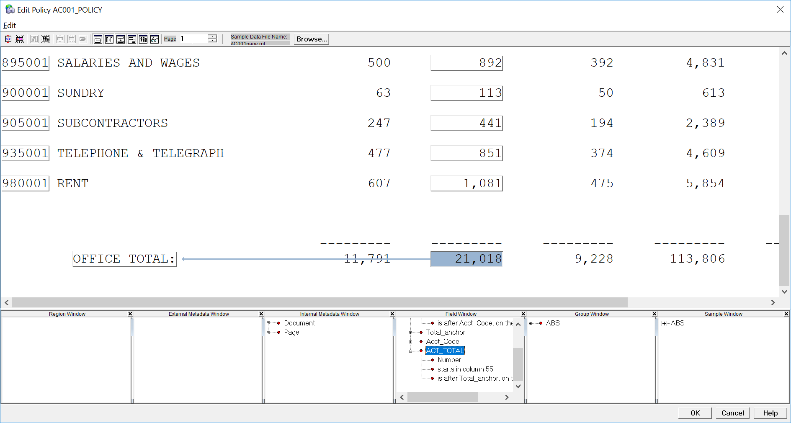

Figure : Edit Policy AC001_POLICY

We can modify a field definition to extract another set of data from a report if required.

1. Click **Cancel** on **Edit Policy** window and click **Close** on **Policy Editor** window.

Creating a Task

1. Select App1 application from the **Applications** screen.

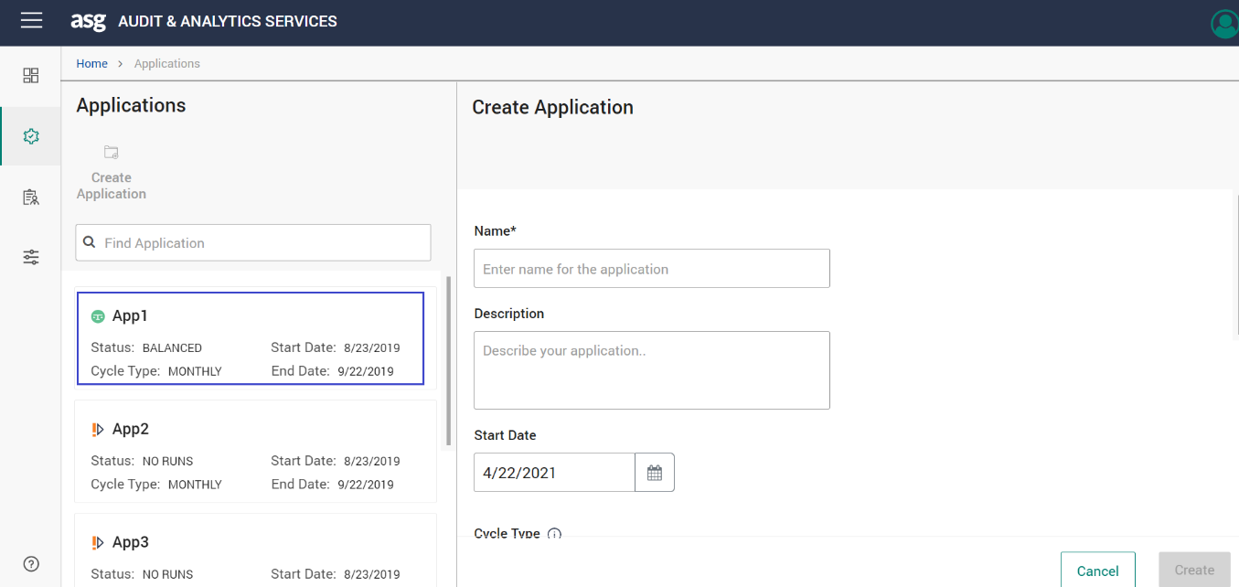

Figure : Select App1

1. Click **Create Folder/Task**.

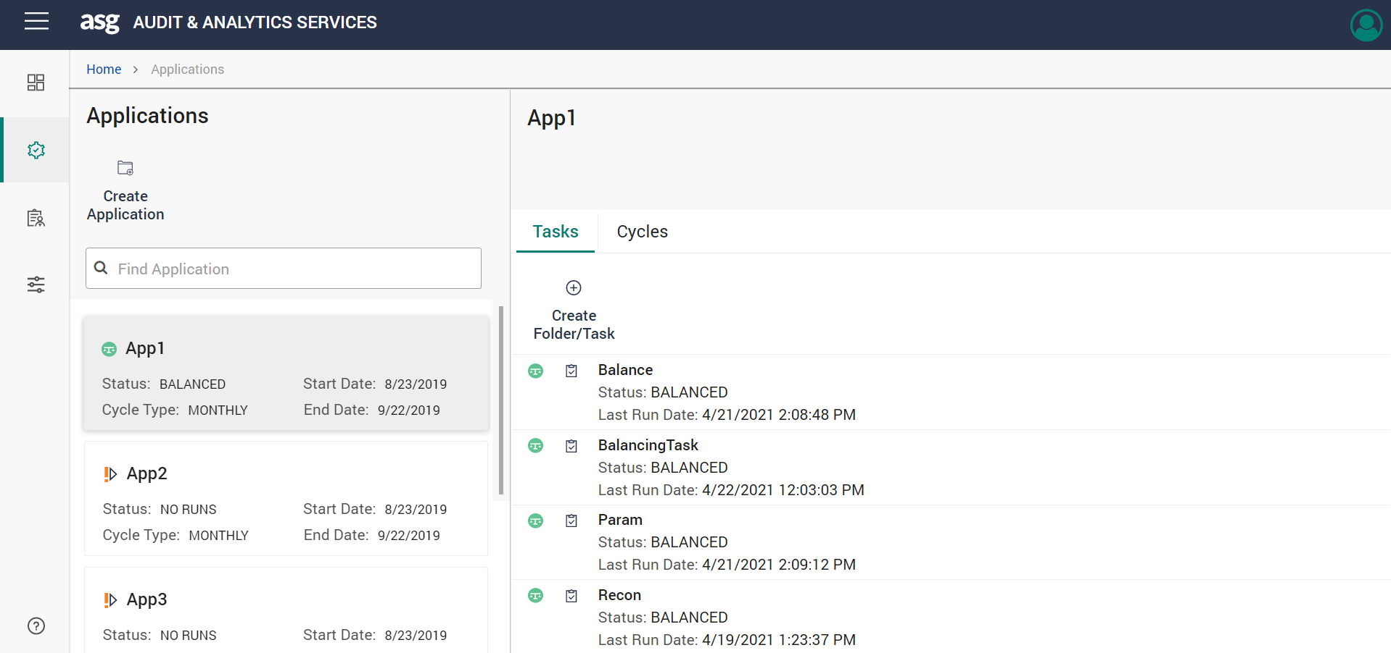

Figure : Create Folder/Task button

1. The **Create Folder/Task** screen appears. Select the **Task** option button.

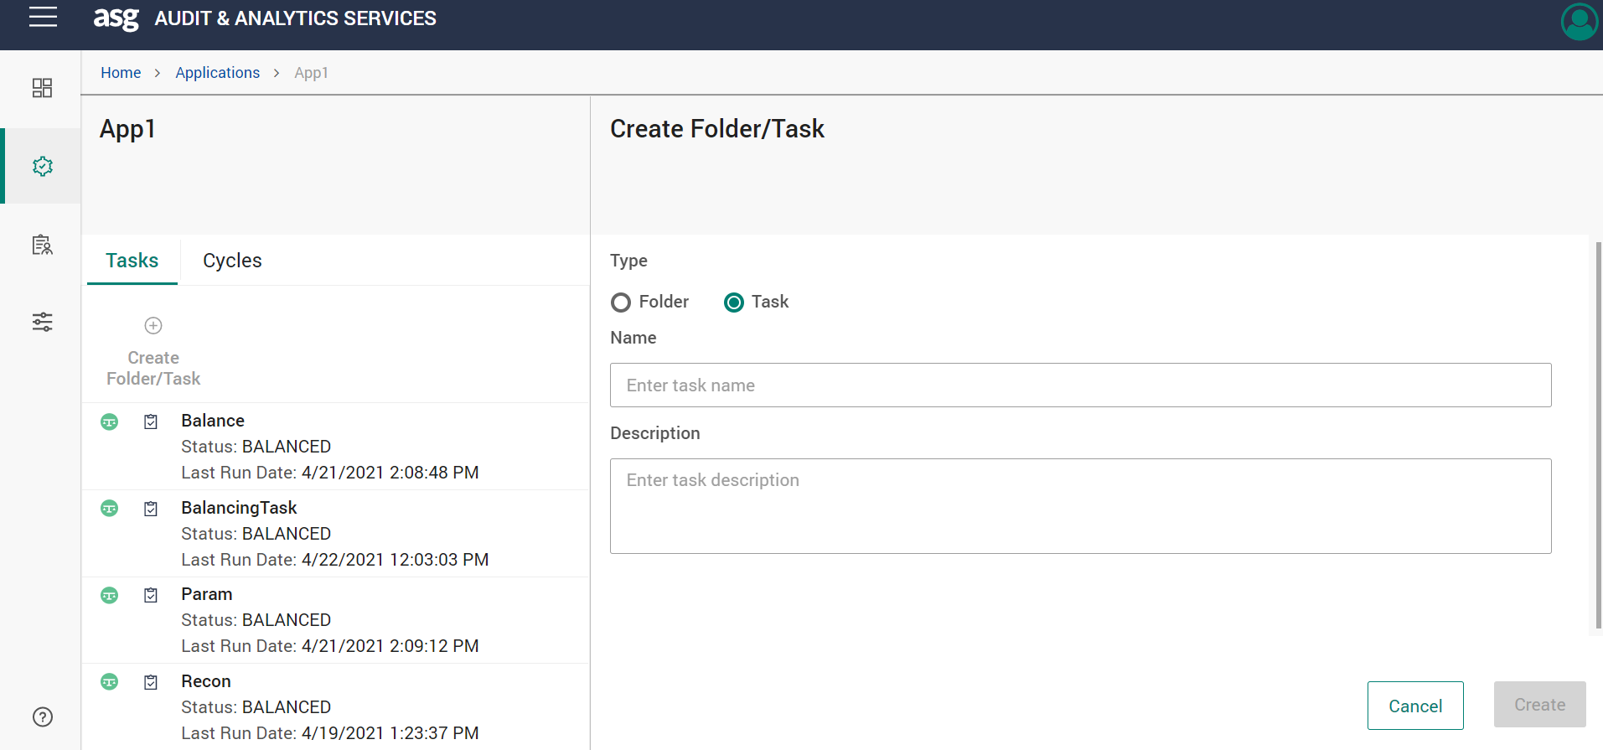

Figure : Create Folder/Task screen

1. Type “BalancingTask” in the **Name** box and click **Create**. A task will be created.

Importing Rule Procedure

1. Launch the Desktop Rule Editor and log in to the application.
2. Go to **Tools** > **Rule Editor** in Audit & Analytics Services application.

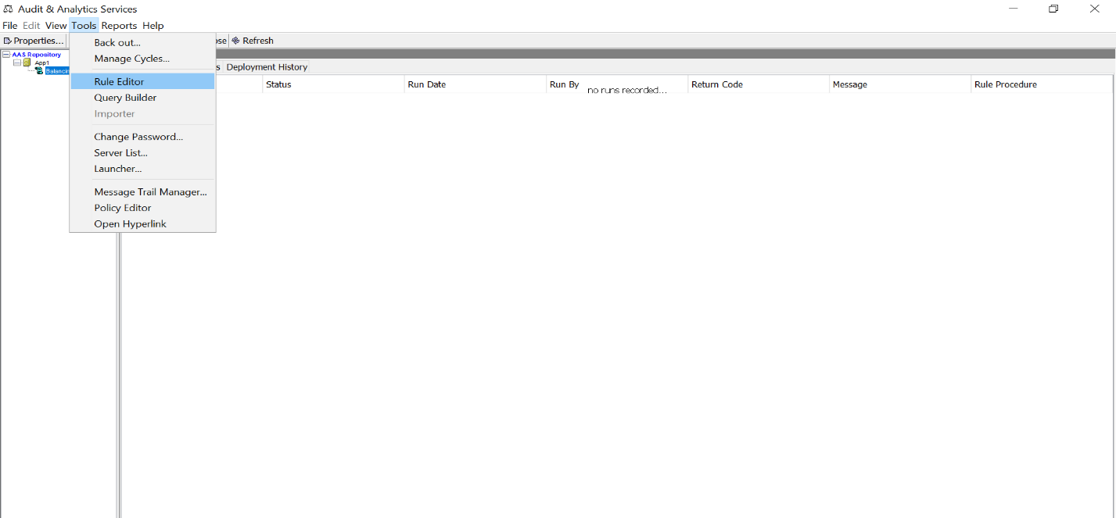

Figure : Rule Editor

1. Click **Open**. The **Open Rule Procedure** window appears as shown in the below image.

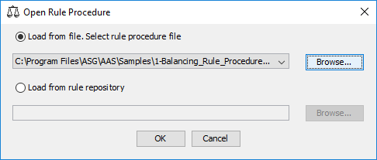

Figure : Open Rule Procedure

1. Click **Browse** and select the BalancingRP.xml file.
2. Click **OK**. The selected rule procedure will be loaded.  
     
   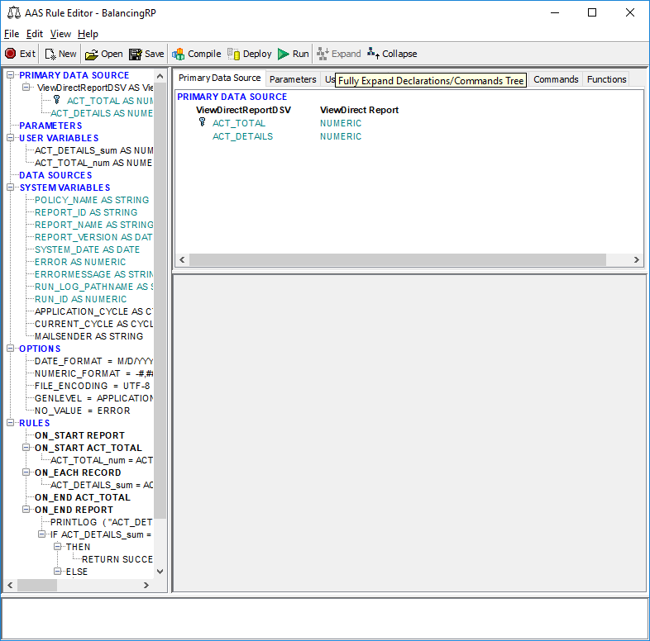

Figure : Rule Procedure Loaded

* A Data Source which would be an input report file has to be defined.

1. Expand **PRIMARY DATA SOURCE** and select ViewDirectReportDSV as ViewDirect Report item as shown in the image above. The ViewDirect Report Source type will use .\Samples\1-Balancing_Rule_Procedure_Demo\DATA\AC001_POLICY.PLC policy to extract data from file .\Samples\1-Balancing_Rule_Procedure_Demo\DATA\AC001page.rpt. There are two fields ACT_TOTAL and ACT_DETAILS that will be extracted from the report.

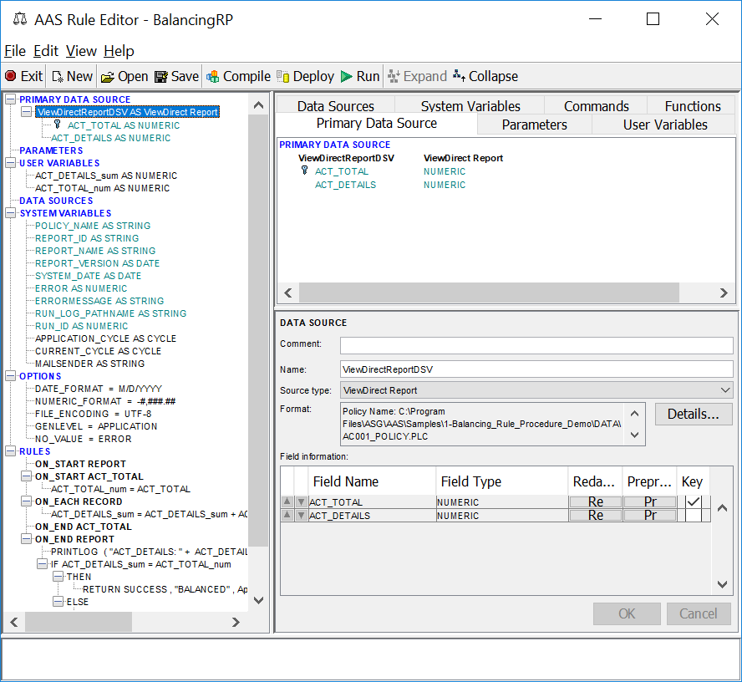

Figure : Primary Data Source

1. After the data source, a variable is required that can hold the data during processing. There are ACT_DETAILS_num and ACT_TOTAL_num numeric variables defined under USER VARIABLES.

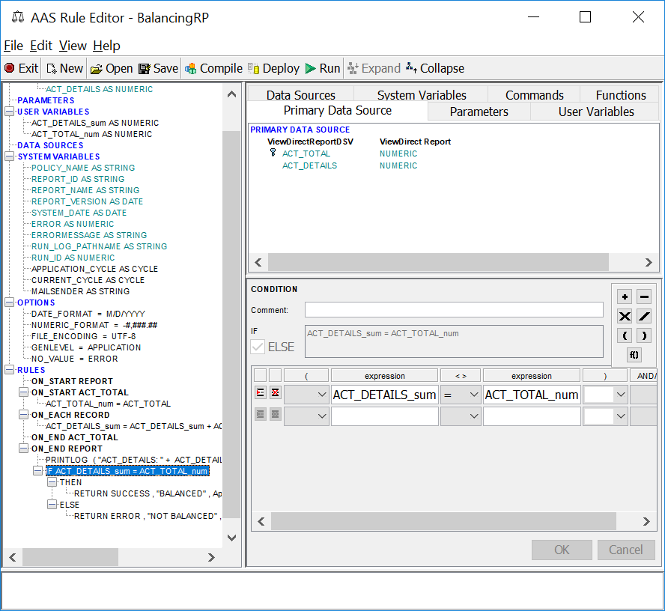

Figure : User Variables

1. After defining the variables, add processing rules. Expand RULES to see a list of rules. Select the first active rule ON_START ACT_TOTAL that has a simple assignment command.



Figure : First Active Rule

Since ACT_TOTAL field value is present just once in a report, ACTTOTAL value is assigned to ACT_TOTAL_num variable at the start of processing.

Under ON_EACH_RECORD rule, ACT_DETAILS_num variable is increased to a value of ACT_DETAILS field values taken from the report row by row. Therefore, there will be a sum of all ACT_DETAILS values from its column, at the end.

Under ON_END_REPORT item, a processing report is printed to Run Log by PRINTLOG command. This is done to know the real value of variables at the end of processing.

Then a CONDITION command checks if ACT_DETAILS_num variable matches the ACT_TOTAL_num variable and returns the appropriate status by RETURN command.

Deploying Rule Procedure

1. Click the **Deploy** button on **AAS Rule Editor** window.
2. The **Deploy RP** dialog box appears. Choose the Name App1/BalancingTask and Click **OK**.

Figure : Deploy RP dialog box

1. The AAS will now deploy the Rule Procedure.

Viewing Run Status and Logs

1. After deploying the Rule Procedure, click **OK**. Close the **Rule Editor** window.
2. Open the browser and hit the URL: http://{hostname/ipaddress}:{port number}/aaservices/view/. For example, <http://local>host:8079/aaservices/view/.
3. Log in to the application using the username and password.
4. Select App1 application and select BalancingTask.
5. Click **Run**. A run logged with its status and message appears.

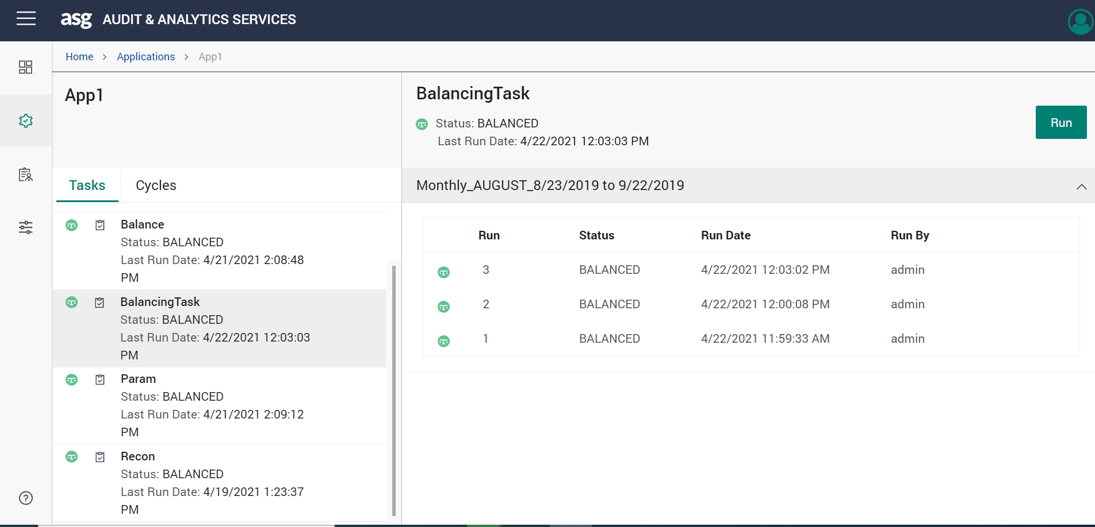

Figure : Run

1. Click the status and select **Run Log** or **Trace Log** to view or download the log.

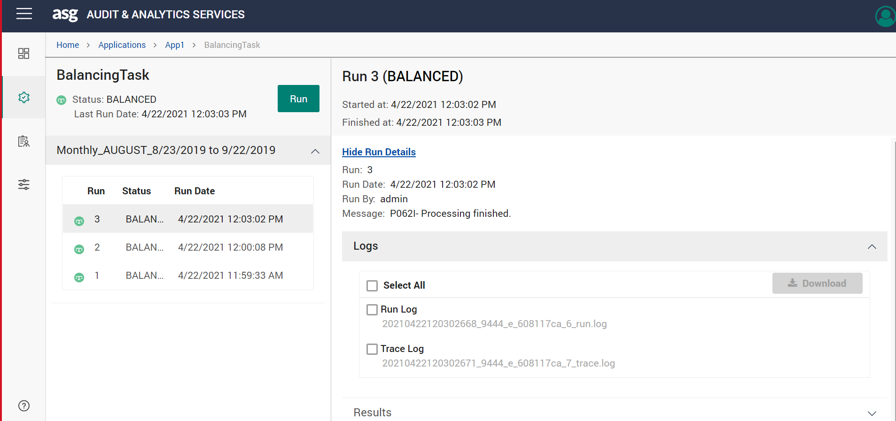

Figure : Run/Trace Log

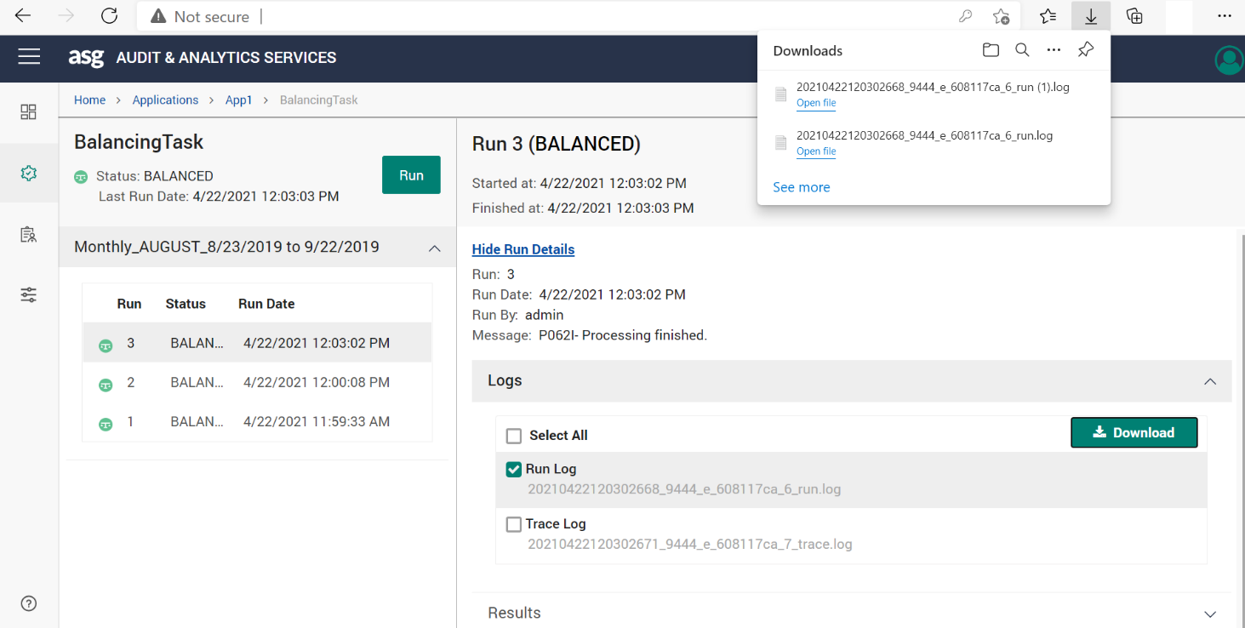

Figure : Download Log File

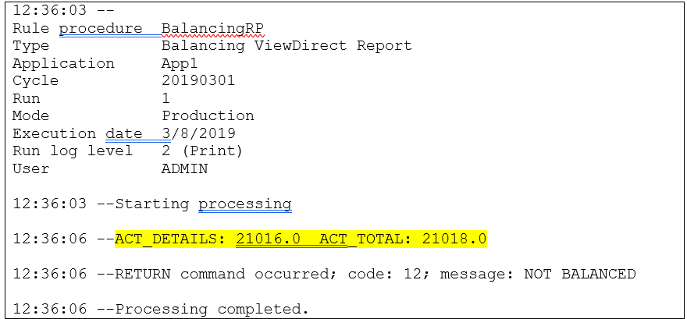

Figure : Log Report

Result

The logs shows that the values of ACT_DETAILS and ACT_TOTAL variables did not match and therefore, the Rule Procedure execution returned an error status with “NOT BALANCED” message.